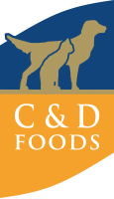

C&D Foods is one of Europe's largest Pet Food Manufacturers. Founded in 1969 in Edgeworthstown, County Longford.
Over the last 50+ years our pet food business has blossomed and now offers manufacturing facilities and sales offices in 14 locations across Europe, with 1,500 employees.

